EXAMPLE ARTIST ITINERARY
Artist #1 – DATE
 | Wednesday 2nd February
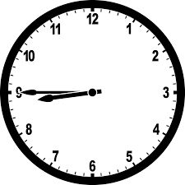 | NAME will pick you up at 08:45am  INSERT PICTURE OF PERSON AND CORRECT TIME
 | You will be rehearsing with NAME and NAME from 9:30am to 4:30pm.
 | At 2pm NAME and NAME will join you all in rehearsals.

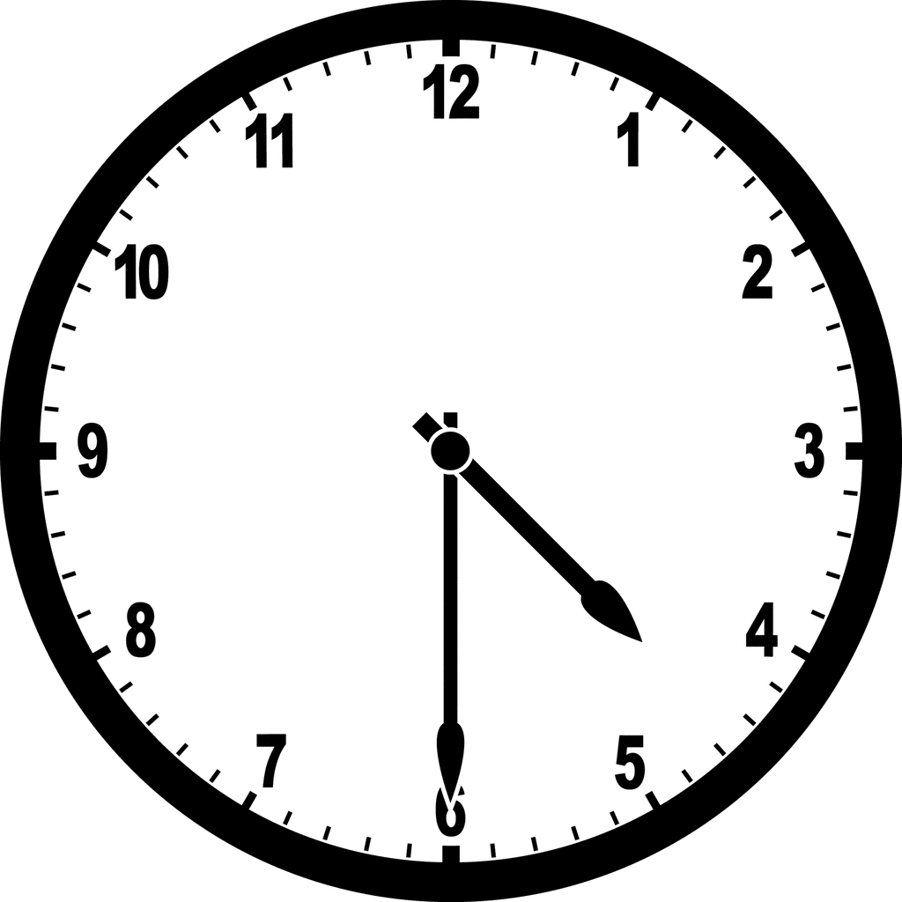 | NAME will bring you home at 4:30pm.  INSERT PICTURE OF PERSON AND CORRECT TIME
Once you are home, you can unwind and relax.

Make sure to get plenty of rest.

If you are needed urgently, someone will phone you.

Things to know

On Tuesday most people will be looking at filming locations so not many people will be in the office.
On Tuesday NAME and NAME will be out of the office all day.
If you need anything please speak to NAME.

Things to Pack/Remember
Remember to bring a water bottle with you – to help the environment!

Remember to bring some money to buy lunch at the canteen.

Remember to bring your scripts for rehearsals.

