WELCOME TO DAY ONE OF PRODUCTION

We want everyone involved with this production to work with
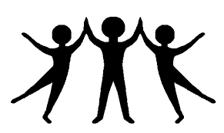
Respect
For each other:
- Please use the Call It app to let us know how you are being treated at work
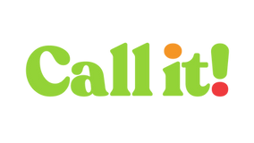
- Please wear a name badge every day as part of our reasonable adjustments for cast and crew
- Please keep your distance and wear a mask

For yourself:
- Let us know if you need time off.
- Let us know if you need any reasonable adjustments
- Don’t check your emails on days off.
- Don’t use your phone at all when driving. You need to keep safe

For the environment:
- Please use the recycling facilities properly.
- Please bring your reusable coffee cup and water bottle
- Please don’t sit in a vehicle with engine running.

and lets have some
Fun
- Work is hard but it can also be fun.
- Laughter at work = warmth on screen!
- And laughter brings better mental health

