EXAMPLE CALL SHEET #1
Wednesday, 23 November 2022
Today we are shooting at the MAIN CHARACTER’S house.

The address is: 1 Example Street, Example Town, Exampleshire, EX1 4MP

 | Today we will be shooting from 8am to 7pm
 | The scenes we are shooting today are: 3/45, 1/27, 2/42, 2/43 and 2/44
Breakfast is served today from 7am to 8am.

There will be choices for breakfast.
 | The time to be ready to work (call time) is 8am.
There will be a short break for lunch at around 1pm.

The break will last for around 1 hour.

Lunch will finish at 2pm.

There will be choices for lunch.
We will finish at 7pm.

Then it is time to go home and relax.
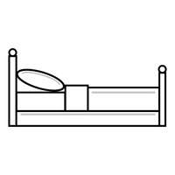 | Please try and rest. No need to check your messages.  If something is urgent your colleague will call.

For more information, please check the detailed call sheet.

